SESSION 14:
TASK 1:
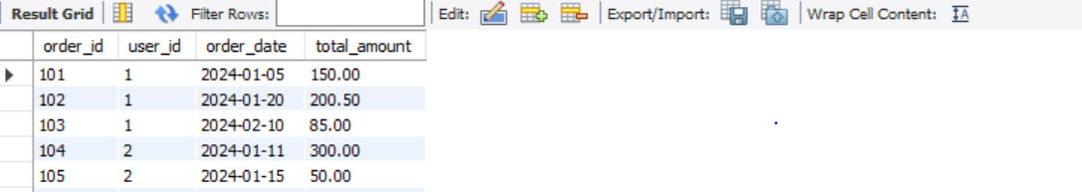

use mydb;
select * from Orde;
CREATE TABLE Orde (
order_id INT PRIMARY KEY,
user_id INT NOT NULL,
order_date DATE NOT NULL,
total_amount DECIMAL(10, 2) NOT NULL
);
INSERT INTO Orde (order_id, user_id, order_date, total_amount) VALUES
(101, 1, '2024-01-05', 150.00),
(102, 1, '2024-01-20', 200.50),
(103, 1, '2024-02-10', 85.00),
(104, 2, '2024-01-11', 300.00),
(105, 2, '2024-01-15', 50.00),
(106, 3, '2024-03-01', 420.00);

select order_id,user_id,order_date,total_amount,
Row_number( )over(Partition by User_id
order by order_date desc) AS user_order_seq
FROM Orde;



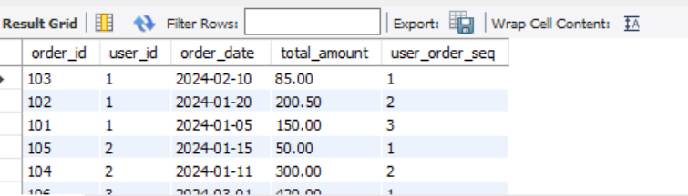

TASK 2:

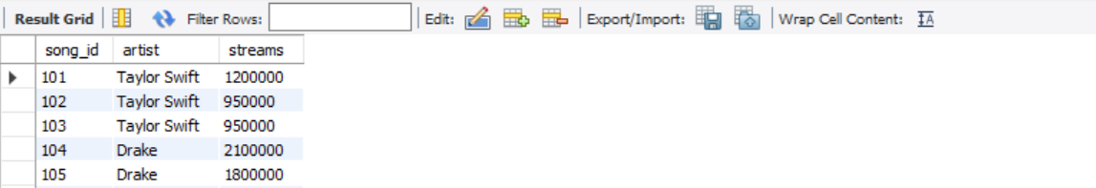
Use mydb;
Select * from songs;
CREATE TABLE Songs (
song_id INT PRIMARY KEY,
artist VARCHAR(100) NOT NULL,
streams INT NOT NULL
);

INSERT INTO Songs (song_id, artist, streams) VALUES
(101, 'Taylor Swift', 1200000),
(102, 'Taylor Swift', 950000),
(103, 'Taylor Swift', 950000),
(104, 'Drake', 2100000),
(105, 'Drake', 1800000),
(106, 'Drake', 1500000);

SELECT
Song_id,
artist,
streams,
Rank() over (Partition by artist order by streams desc) as song_rank
FROM Songs;
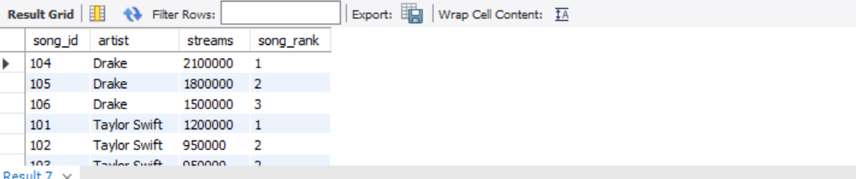

TASK 3:



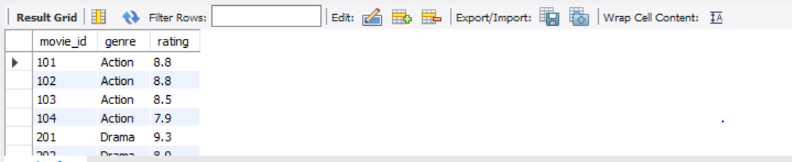

Use mydb;
select * from movies;
CREATE TABLE Movies (
movie_id INT PRIMARY KEY,
genre VARCHAR(50) NOT NULL,
rating DECIMAL(3, 1) NOT NULL
);

-- Insert sample records
INSERT INTO Movies (movie_id, genre, rating) VALUES
(101, 'Action', 8.8),
(102, 'Action', 8.8),
(103, 'Action', 8.5),
(104, 'Action', 7.9),
(201, 'Drama', 9.3),
(202, 'Drama', 8.9),
(203, 'Drama', 8.9),
(204, 'Drama', 8.1);

Select movie_id, genre, rating , dense_rank ()over(Partition by genre Order by rating desc) as rating_rank from Movies;

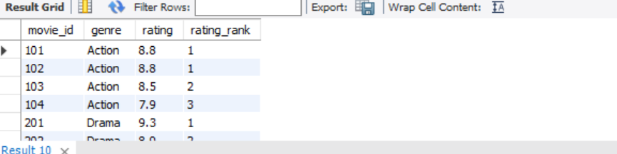

TASK 4:
With RankedInfluencers as (Select id,platform, followers, Row_Number()over(partition by platform order by followers desc) as row_num from influencers)
SELECT
id,
platform,
followers,
row_num
FROM RankedInfluencers
WHERE row_num <= 3;

